The Third International Workshop on Development and Application of High-Order Numerical Methods

School of Mathematical Sciences

University of Science and Technology of China

December 16-19, 2016

Table of Contents

Organization………………………………………………………………………………………………………………………………..

Useful Information……………………………………………………………………………………………………………………….

Schedule by Day……………………………………………………………………………………………………………………………

Plenary Talk………………………………………………………………………………………………………………………………….

Invited Talk…………………………………………………………………………………………………………………………………..

Poster……………………………………………………………………………………………………………………………………………

Appendix: Xinqiao Airport map…………………………………………………………………………………………………….

Hefei Railway Station map ……………………………………………………………………………………………………………

Hefei South Railway Station map…………………………………………………………………………………………………..

School map …………………………………………………………………………………………………………………………………..

Hotel and Venue maps………………………………………………………………………………………………………………….

Organization

The purpose of this workshop series is to bring together researchers in computational and applied mathematics to discuss recent advances on the theoretical, computational and applied aspects of high-order methods for the solution of partial differential equations.
Scientific Committee:

Falai Chen, University of Science and Technology of China
Weinan E (Chair), Princeton University and Beijing Institute of Big Data Research
Sigal Gottlieb, University of Massachusetts Dartmouth
Tao Tang, South University of Science and Technology
Qiang Zhang, Nanjing University

Organizing Committee:

Juan Cheng, Institute of Applied Physics and Computational Mathematics
Jianxian Qiu (co-Chair), Xiamen University
Yinhua Xia, University of Science and Technology of China
Yan Xu, University of Science and Technology of China
Mengping Zhang (co-Chair), University of Science and Technology of China

Sponsors

School of Mathematical Sciences, University of Science and Technology of China

Emergency Contact：

Yong Liu（Tel: 17707919816）Email: yong123@mail.ustc.edu.cn

Liangze Yang （Tel: 15212796871）Email: lzeyang@mail.ustc.edu.cn

Kaipeng Wang（Tel：13637066995）Email: wangkp@mail.ustc.edu.cn

Yuan Liu（Tel: 15375443651 ）Email: yl686@msstate.edu

Mengping Zhang （Tel: 13505608176）Email: mpzhang@ustc.edu.cn

Useful Information

Venue

Academic Lecture Hall, School of Management, 2/F, Management R&D Building, USTC

（中国科学技术大学管理科研楼2楼，管理学院学术报告厅）

Address: No. 96, Jinzhai Road, Baohe District, Hefei, Anhui, China.

（中国科学技术大学东校区地址：安徽省合肥市包河区金寨路96号）

Registration

The registration will be held from 9:00 to 24:00, December 16, Guest House, University of Science and Technology of China （中国科学技术大学专家楼）, No. 96, Jinzhai Road, Baohe District, Hefei, Anhui, China, （包河区金寨路96号）Telephone: 0551-63602878

Hotel

Guest House, University of Science and Technology of China,（中国科学技术大学专家楼） No. 96, Jinzhai Road, Baohe District, Hefei, Anhui, China, （包河区金寨路96号）Telephone: 0551-63602878

Breakfast: Hotel rate has already included breakfast.

Transportation Information
- From Xinqiao International Airport to USTC, Taxi fee around ￥100 Yuan
- From Hefei south Railway Station to USTC, Taxi fee around ￥25 Yuan
- From Hefei Railway Station to USTC, Taxi fee around ￥25 Yuan

Main Schedule
Date | Time | Contents | Place
Dec. 16 | 9:00-24:00 | Registration | Guest House, USTC
 | 18:00-19:00 | Dinner
Dec. 17 | 7:00-8:30 | Breakfast | Guest House, USTC
 | 8:30-9:00 | Opening Ceremony | Academic Lecture Hall, School of Management
 | 9:00-10:50 | Plenary Talk
 | 10:50-12:05 | Invited Talk
 | 12:00-13:00 | Lunch | Guest House, USTC
 | 14:00-15:30 | Plenary Talk | Academic Lecture Hall, School of Management
 | 15:30-15:50 | Break
 | 15:50-17:05 | Invited Talk
 | 18:30- | Banquet | Guest House, USTC
Dec. 18 | 7:00-8:30 | Breakfast | Guest House, USTC
 | 8:30-10:00 | Plenary Talk | Academic Lecture Hall, School of Management
 | 10:00-10:20 | Break
 | 10:20-12:00 | Invited Talk
 | 12:00-13:00 | Lunch | Guest House, USTC
 | 14:00-15:40 | Invited Talk | Academic Lecture Hall, School of Management
 | 15:40-16:00 | Break
 | 16:00-17:40 | Invited Talk
 | 18:00-19:00 | Dinner | Guest House, USTC
Dec. 19 | 7:00-8:30 | Breakfast | Guest House, USTC
 | 8:30-9:15 | Plenary Talk | Academic Lecture Hall, School of Management
 | 9:15-10:05 | Invited Talk
 | 10:05-10:25 | Break
 | 10:25-11:40 | Invited Talk
 | 11:40-12:05 | Closing Ceremony
 | 12:00-13:00 | Lunch | Guest House, USTC

Schedule by Day
2016-12-17，Saturday，8:30-17:10
Time
8:30-9:00 | Opening Ceremony | Chair：  Qiang Du(杜强)
9:00-9:45 | Plenary Talk：Yongtao Zhang （张勇涛）  Professor Chi-Wang Shu's Contributions in Academics
9:45-10:05 | Break
10:05-10:50 | Plenary Talk：Zhimin Zhang （张智民）  We Still Can Get Enough of Layers ... buy Why?
10:50-11:15 | Fengyan Li （李凤艳）  Fully Discrete Energy Stable DG Methods for Maxwell’s  Equations in Nonlinear Media
11:15-11:40 | Juan Cheng （成娟）  High order positivity-preserving DG schemes for radiation transfer equat
11:40-12:05 | Qiang Zhang （张强）  Some optimal error estimates of local discontinuous Galerkin method when solving convection diffusion equations
12:00-13:00 | Lunch time
14:00-14:45 | Plenary Talk：Hongkai Zhao （赵宏凯）  Learning adaptive basis for ray-based finite element method for the high-frequency Helmholtz equation | Chair：Zhimin Zhang (张智民)
14:45-15:30 | Plenary Talk：Tao Tang（汤涛）  High order numerical methods for uncertainty quantification
15:30-15:50 | Break
15:50-15:15 | Jue Yan （阎珏）  DDGIC and symmetric DDG methods for chemotaxis Keller-Segel equations
15:15-16:40 | Zhengfu Xu （徐正富）  Bound-preserving flux limiter and total variation stability
11:40-17:05 | Gang Li （李刚）  Well-balanced DG methods for the Euler equations under gravitational fields

2016-12-18，Sunday，8:30-17:35
Time
8:30-9:15 | Plenary Talk：Weinan E （鄂维南）  Theory and application of stochastic gradient algorithms | Chair：  Chi-Wang Shu (舒其望)
9:15-10:00 | Plenary Talk：Qiang Du （杜强）  Nonlocal models with a finite range of nonlocal interactions
10:00-10:20 | Break
10:20-10:45 | Jennifer Ryan  One Dimensional SIAC filtering for Multi-dimensional data
10:45-11:10 | Kurt Sebastian  Multidomain WENO with Interpolation at Subdomain Interfaces
11:10-11:35 | Ching-Shan Chou （仇竟珊）  Hyperbolic Conservation Law in Stem Cell Biology
11:35-12:00 | Shuhai Zhang （张树海）  Numerical simulation for the Aeroacoustic wave propagating in flow
12:00-13:00 | Lunch time
14:00-14:25 | Yulong Xing （邢雨龙）  Local Discontinuous Galerkin Methods for the Coupled BBM-BBM System | Chair：  Wei Cai  (蔡伟)
14:25-14:50 | Yingda Cheng （程颖达）  A Sparse Grid Discontinuous Galerkin Method for High-Dimensional Transport Equations
14:50-15:15 | Xiangxiong Zhang（张翔雄）  Positivity-preserving high order discontinuous Galerkin schemes for compressible Navier-Stokes equations
16:00-16:25 | Xinghui Zhong（仲杏慧）  Compact WENO Limiters for DG methods
15:15-15:40 | Yang Yang （杨扬）  Discontinuous Galerkin method for miscible displacement problem in porous media
15:40-16:00 | Break
16:25-16:50 | Tao Xiong （熊涛）  On the asymptotic limit of the Vlasov-Maxwell system with a large magnetic field
16:50-17:15 | Yan Xu （徐岩）  Discontinuous Galerkin approximations for computing electromagnetic bloch modes in photonic crystals
17:15-17:40 | Jianxian Qiu（邱建贤）  A new type of modified WENO schemes for solving hyperbolic conservation laws

2016-12-19，Monday，上午：8:30-12:05
Time
8:30-9:15 | Plenary Talk：Wei Cai（蔡伟）  High Order Hierarchical Divergence-free Constrained Transport H(div) Finite Element Method for Magnetic Induction Equation | Chair：  Juan Cheng  (成娟)
9:15-9:40 | Cheng Wang （王成）  Large scale parallel high precision software of explosion and impact problems
9:40-10:05 | Yuan Liu （刘媛）  High order operator splitting methods based on an integral deferred correction framework
10:05-10:25 | Break
10:25-10:50 | Xiong Meng （孟熊）  Optimal error estimates for discontinuous Galerkin methods based on upwind-biased fluxes for linear hyperbolic equations
10:50-11:15 | Yinhua Xia（夏银华）  Arbitrary Lagrangian-Eulerian discontinuous Galerkin method for conservation laws
11:15-11:40 | Mengping Zhang（张梦萍）  Optimal error estimates of the semidiscrete central discontinuous Galerkin methods for linear hyperbolic equations
11:40-12:00 | Closing Ceremony

Abstract

Poster

通讯录

Name |  | Work unit
English | 中文 | English | 中文 | Email
Jing An | 安静 | Beijing Computational Science Research Center | 北京计算科学研究中心 | anjing@csrc.ac.cn
Wei Cai | 蔡伟 | University of North Carolina at Charlotte and Beijing Computational Science Research Center | 北卡罗来纳大学夏洛特分校，北京计算科学研究中心 | wcai@uncc.edu
Waixiang Cao | 曹外香 | Beijing Computational Science Research Center | 北京计算科学研究中心 | wxcao@csrc.ac.cn
Xin Chen | 陈新 | University of Science and Technology of China | 中国科学技术大学 | cx1995@mail.ustc.edu.cn
Juan Cheng | 成娟 | Institute of Applied Physics and Computational Mathematics | 北京应用物理与计算数学研究所 | chengjuan_bj@foxmail.com
Yao Cheng | 程瑶 | Suzhou Unviersity of Technology and Science | 苏州科技大学 | chengyao2156@163.com
Yingda Cheng | 程颖达 | Michigan State University | 密歇根州立大学 | ycheng@math.msu.edu
Ziqiang Cheng | 程自强 | University of Science and Technology of China | 中国科学技术大学 | czq10491@mail.ustc.edu.cn
Ching-Shan Chou | 仇竟珊 | Ohio State University | 俄亥俄州立大学 | chou@math.osu.edu
Shengrong Ding | 丁生荣 | University of Science and Technology of China | 中国科学技术大学 | dsr9208@mail.ustc.edu.cn
Haixia Dong | 董海霞 | Beijing Computational Science Research Center | 北京计算科学研究中心 | hxdong@csrc.ac.cn
Jie Du | 杜洁 | The Chinese University of Hong Kong | 香港中文大学 | jdu@math.cuhk.edu.hk
Qiang Du | 杜强 | Columbia University and Beijing Computational Science Research Center | 哥伦比亚大学，北京计算科学研究中心 | qdu@csrc.ac.cn
Shaohong Du | 杜绍洪 | Beijing Computational Science Research Center | 北京计算科学研究中心 | dushaohong@csrc.ac.cn
Yu Du | 杜宇 | Beijing Computational Science Research Center | 北京计算科学研究中心 | duyu87@csrc.ac.cn
Duan Yali | 段雅丽 | University of Science and Technology of China | 中国科学技术大学 | ylduan01@ustc.edu.cn

Weinan E | 鄂维南 | Princeton University and Beijing Institute of Big Data Research | 普林斯顿大学，北京大数据研究院 | weinan@math.princeton.edu
Pei Fu | 付培 | University of Science and Technology of China | 中国科学技术大学 | sxfp2013@mail.ustc.edu.cn
Hui Guo | 郭会 | China University of Petroleum | 中国石油大学 | sdugh@163.com
Li Guo | 郭莉 | Sun Yat-Sen University | 中山大学 | lili2010@mail.ustc.edu.cn
Ruihan Guo | 郭瑞晗 | Zhengzhou University | 郑州大学 | guoguo88@mail.ustc.edu.cn
Xue Hong | 洪雪 | University of Science and Technology of China | 中国科学技术大学 | xuehong1@mail.ustc.edu.cn
Juntao Huang | 黄俊涛 | Tsinghua University | 清华大学 | huangjt13@mails.tsinghua.edu.cn
Ling Huang | 黄玲 |  |  | huangl0@mail.ustc.edu.cn
Robert Jiang | 姜广山 | AIG | 美亚保险 | gsjiang@yahoo.com
Yan Jiang | 蒋琰 | Michigan State University | 密歇根州立大学 | jiangyan@math.msu.edu
Linghua Kong | 孔令华 | Jiangxi Normal University | 江西师范大学 | konglh@mail.ustc.edu.cn
Dan Li | 李丹 | Beijing Computational Science Research Center | 北京计算科学研究中心 | danli@csrc.ac.cn
Fengyan Li | 李凤艳 | Rensselaer Polytechnic Institute | 伦斯勒理工学院 | lif@rpi.edu
Gang Li | 李刚 | Qingdao University | 青岛大学 | gangli1978@163.com
Ying Li | 李颖 | Shanghai University | 上海大学 | yinglotus@t.shu.edu.cn
liling lin | 林丽玲 | Xiamen University | 厦门大学 | linll00@163.com
Hongxia Liu | 刘红霞 | Taiyuan University of Technology | 太原理工大学 | hx_ryu@163.com
Jianming Liu | 刘剑明 | Jiangsu Normal University | 江苏师范大学 | jmliu@jsnu.edu.cn
Wei Liu | 刘伟 | Chinese Academy of Sciences | 中国科学院 | lwyawa@gmail.com
Yong Liu | 刘勇 | University of Science and Technology of China | 中国科学技术大学 | yong123@mail.ustc.edu.cn
Yuan Liu | 刘媛 | Mississippi State University | 密西西比州立大学 | yl686@msstate.edu
Yunxian Liu | 刘蕴贤 | Shandong University | 山东大学 | yxliu@sdu.edu.cn
Jianfang Lu | 卢键方 | Beijing Computational Science Research Center | 北京计算科学研究中心 | jflu@csrc.ac.cn

Zhongjie Lu | 鲁仲杰 | University of Science and Technology of China | 中国科学技术大学 | zhjlu@mail.ustc.edu.cn
Suna Ma | 马苏娜 | Beijing Computational Science Research Center | 北京计算科学研究中心 | masuna@csrc.ac.cn
Tian Ma | 马天 | University of Science and Technology of China | 中国科学技术大学 | Diamond8@mail.ustc.edu.cn
Xiangyi Meng | 孟祥义 | University of Science and Technology of China | 中国科学技术大学 | mxy6@mail.ustc.edu.cn
Xiong Meng | 孟雄 | Harbin Institute of Technology | 哈尔滨工业大学 | xiongmeng@hit.edu.cn
Jiajia Niu | 牛嘉佳 | UTC | 联合技术公司 | jiajia.niu@carrier.utc.com
Jianxian Qiu | 邱建贤 | Xiamen University | 厦门大学 | jxqiu@xmu.edu.cn
Jennifer Ryan |  | University of East Anglia | 东英吉利大学 | Jennifer.Ryan@uea.ac.uk
Kurt Sebastian |  | Flagler College | 弗拉格勒学院 | ksebastian@flagler.edu
Gero Schnücke |  | University of Würzburg |  | gero.schnuecke@web.de
Jing Shi | 石靖 | Beijing Institute of Technology | 北京理工大学 | jshi@bit.edu.cn
Xiaotian Shi | 时晓天 | China Academy of Aerospace Aerodynamics | 中国航天空气动力技术研究院 | xxtshi@163.com
Chi-Wang Shu | 舒其望 | Brown University | 布朗大学 | shu@dam.brown.edu
Chong Sun | 孙冲 | University of Science and Technology of China | 中国科学技术大学 | sc1500@mail.ustc.edu.cn
Tao Tang | 汤涛 | South University of Science and Technology | 南方科技大学 | tangt@sustc.edu.cn
Qi Tao | 陶琪 | University of Science and Technology of China | 中国科学技术大学 | taoq@mail.ustc.edu.cn
Cheng Wang | 王成 | Beijing Institute of Technology | 北京理工大学 | wangcheng@bit.edu.cn
Chunwu Wang | 王春武 | Nanjing University of Aeronautics and Astronautics | 南京航空航天大学 | wangcw@nuaa.edu.cn
Haijin Wang | 王海金 | Nangjing University of Posts and Telecommunications | 南京邮电大学 | hjwang@njupt.edu.cn
Jiangxin Wang | 王疆兴 | Beijing Computational Science Research Center | 北京计算科学研究中心 | jxwang@csrc.ac.cn
Jin Wang | 王进 | University of Tennessee at Chattanooga
Kaipeng Wang | 王恺鹏 | University of Science and Technology of China | 中国科学技术大学 | wangkp@mail.ustc.edu.cn
Shiping Wang | 王诗平 | Harbin Engineering University | 哈尔滨工程大学 | wangshiping@hrbeu.edu.cn
Yinhua Xia | 夏银华 | University of Science and Technology of China | 中国科学技术大学 | yhxia@ustc.edu.cn
Shusen Xie | 谢树森 | School of Mathematical Sciences, Ocean University of China | 中国海洋大学 | shusenxie@ouc.edu.cn
Yulong Xing | 邢雨龙 | University of California Riverside | 加州大学河滨分校 | xingy@ucr.edu
Tao Xiong | 熊涛 | Institut de Mathématiques de Toulouse and Xiamen University | 厦门大学 | txiong@xmu.edu.cn
Chengjun Xu | 徐丞君 | University of Science and Technology of China | 中国科学技术大学 | xucjh@mail.ustc.edu.cn
Liwei Xu | 徐立伟 | University of Electronic Science and Technology of China | 电子科技大学 | xul@uestc.edu.cn
Yan Xu | 徐岩 | University of Science and Technology of China | 中国科学技术大学 | yxu@ustc.edu.cn
Zhengfu Xu | 徐正富 | Michigan Tech University | 密西根理工大学 | zhengfux@mtu.edu
Ziyao Xu | 徐梓尧 | China University of Petroleum | 中国石油大学 | upc_xuzy@163.com
Fengna Yan | 闫凤娜 | University of Science and Technology of China | 中国科学技术大学 | yfnlj@mail.ustc.edu.cn
Jue Yan | 阎珏 | Iowa state university | 爱荷华州立大学 | jyan@iastate.edu
Wenjing Yan | 晏文璟 | Xi'an Jiaotong University | 西安交通大学 | wenjingyan@xjtu.edu.cn
Liangze Yang | 杨良泽 | University of Science and Technology of China | 中国科学技术大学 | lzeyang@mail.ustc.edu.cn
Xiaobo Yang | 杨晓波 | China University of Mining and Technology | 中国矿业大学 | xwindyb@126.com
Yang Yang | 杨扬 | Michigan Technological University | 密歇根理工大学 | yyang7@mtu.edu
Fan Yu | 余帆 | China University of Petroleum | 中国石油大学 | yufanliyun@163.com
Yize Yu | 余亦泽 | University of Science and Technology of China | 中国科学技术大学 | yyz77@mail.ustc.edu.cn
Aman Zhang | 张阿漫 | Harbin Engineering University | 哈尔滨工程大学 | zhangaman@hrbeu.edu.cn
Chris Cheung | 张超 | University of Science and Technology of China | 中国科学技术大学 | zc56@mail.ustc.edu.cn
Mengping Zhang | 张梦萍 | University of Science and Technology of China | 中国科学技术大学 | mpzhang@ustc.edu.cn
Min Zhang | 张敏 | Xiamen University | 厦门大学 | zhangminyzd@aliyun.com
Qian Zhang | 张茜 | University of Science and Technology of China | 中国科学技术大学 | gelee@mail.ustc.edu.cn
Qian Zhang | 张倩 | Beijing Computational Science Research Center | 北京计算科学研究中心 | qianzhang@csrc.ac.cn
Qiang Zhang | 张强 | Nanjing University | 南京大学 | qzh@nju.edu.cn
Rui Zhang | 张瑞 | University of Science and Technology of China | 中国科学技术大学 | rui@ustc.edu.cn
Shuhai Zhang | 张树海 | China Aerodynamics Research and Development Center | 中国空气动力研究与发展中心 | shuhai_zhang@163.com
Weijie Zhang | 张伟杰 | University of Science and Technology of China | 中国科学技术大学 | zhwj@mail.ustc.edu.cn
Xiangxiong Zhang | 张翔雄 | Purdue University | 普渡大学 | zhan1966@purdue.edu
Yongtao Zhang | 张勇涛 | University of Notre Dame | 圣母大学 | yzhang10@nd.edu
Zhimin Zhang | 张智民 | Wayne State University and Beijing Computational Science Research Center | 美国韦恩州立大学，北京计算科学研究中心 | zmzhang@csrc.ac.cn
Di Zhao | 赵迪 | Nanjing University | 南京大学 | jszhaodi@126.com
Hongkai Zhao | 赵宏凯 | University of California, Irvine | 加利福尼亚大学欧文分校 | zhao@math.uci.edu
Jianli Zhao | 赵建丽 | University of Science and Technology of China | 中国科学技术大学 | zjl88914@mail.ustc.edu.cn
Qi Zhao | 赵琪 | University of Science and Technology of China | 中国科学技术大学 | zhqay@mail.ustc.edu.cn
Wengeng Zhao | 赵文赓 | China Academy of Aerospace Aerodynamics | 中国航天空气动力技术研究院 | zhaowengeng12@126.com
Xuan Zhao | 赵璇 | Southeast University | 东南大学 | xuanzhao11@seu.edu.cn
Zhuang Zhao | 赵状 | Xiamen University | 厦门大学 | zhaozhuang_xmu@163.com
Feng Zheng | 郑锋 | Xiamen Univeristy | 厦门大学 | fzbz200808-31@163.com
Eric Chung | 種子信 | The Chinese University of Hong Kong | 香港中文大学 | tschung@math.cuhk.edu.hk
Xinghui Zhong | 仲杏慧 | Zhejiang University | 浙江大学 | zhongxh@zju.edu.cn
Lingling Zhou | 周玲玲 | University of Science and Technology of China | 中国科学技术大学 | zl1991@mail.ustc.edu.cn
Tie Zhou | 周铁 | Peking University | 北京大学 | tzhou@math.pku.edu.cn
Hongqiang Zhu | 朱洪强 | Nanjing University of Posts and Telecommunications | 南京邮电大学 | zhuhq@njupt.edu.cn

Appendix: Maps

From Xinqiao International Airport to Guest House, University of Science and Technology of China （从合肥新桥机场到中国科学技术大学东区专家楼）

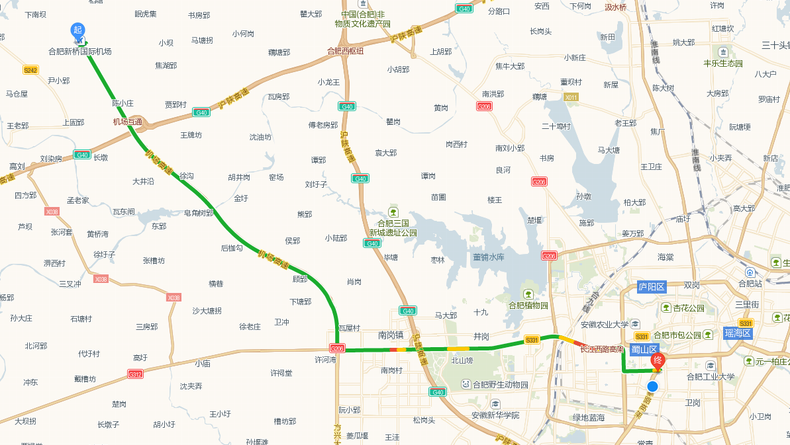

出租车约行驶45分钟，费用约为100元；

公交可乘坐机场巴士5号线（新桥机场站至桐江饭店站）步行至省儿童医院站乘坐108路公交车（植物园方向06:00-22:30）至中国科学技术大学站，大约2小时。

From Hefei Railway Station to Guest House, University of Science and Technology of China（从合肥火车站到中国科学技术大学东区专家楼）

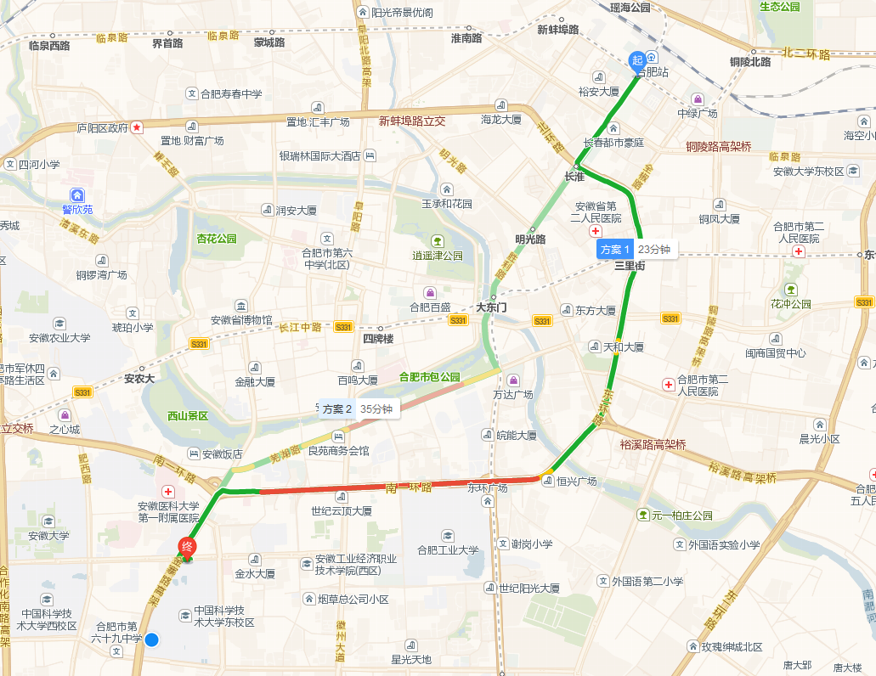

出租车约行驶15分钟，费用约为25元；

公交可乘坐1路（南门换乘中心方向05:00-22:30，火车站至中国科学技术大学站），10路（06:00-22:00），129路（06:00-21:30）（站前广场站至中国科学技术大学站），大约45分钟。

From Hefei South Railway Station to Guest House, University of Science and Technology of China（从合肥南站到中国科学技术大学东区专家楼）

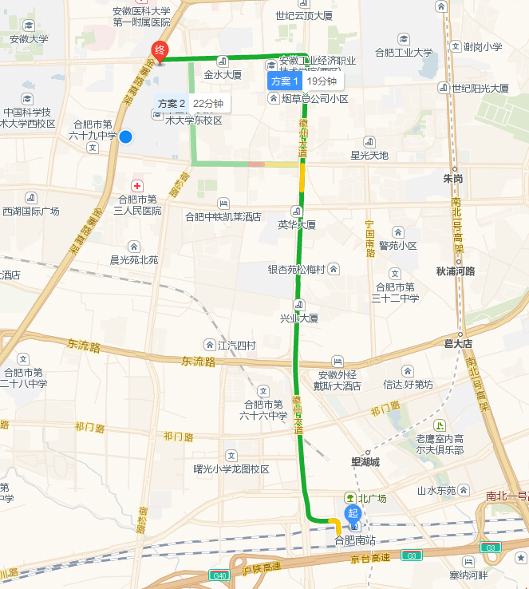

出租车约行驶15分钟，费用约为25元；

公交可乘坐108路（植物园方向06:00-22:30）合肥南站北广场站至中国科学技术大学站，大约40分钟。

School Map:

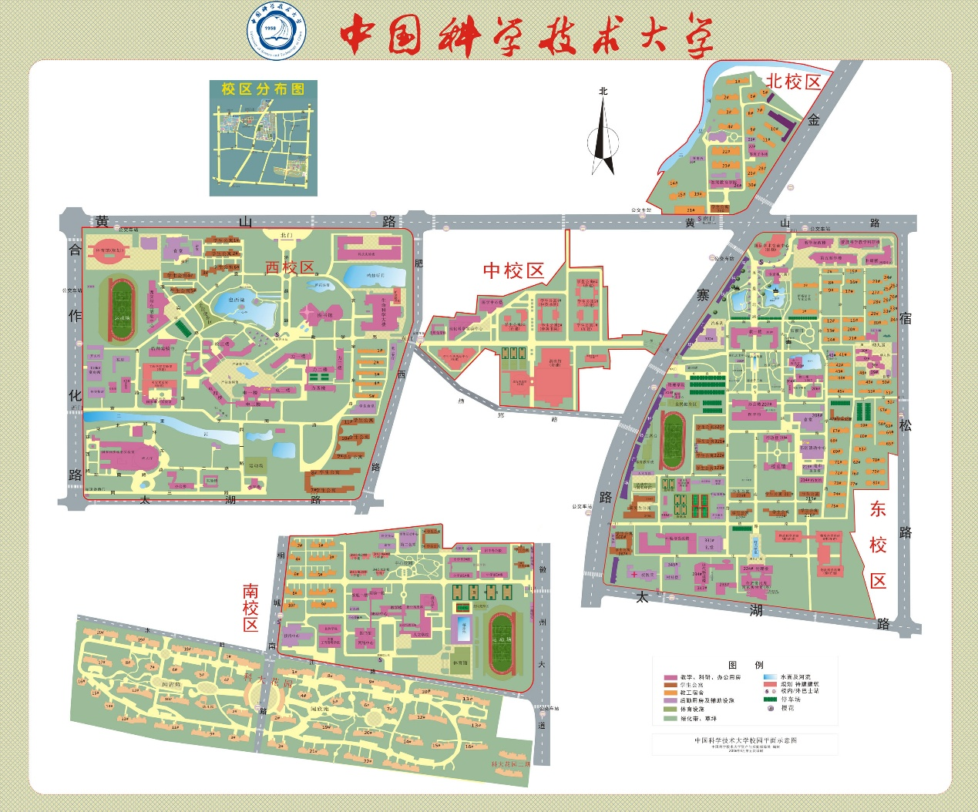

Hotel and Venue maps:

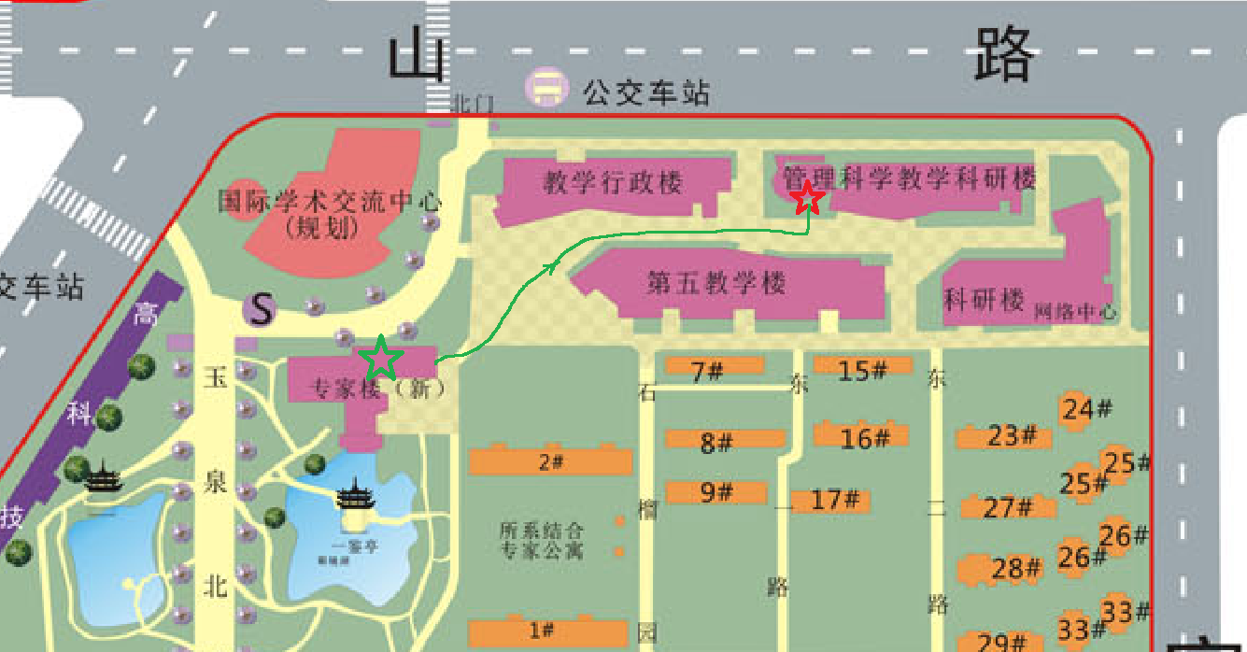

注：

图中：绿色五角星表示专家楼位置（住宿），红色五角星表示报告厅位置。沿绿色线箭头方向可以从专家楼到达报告厅。

